**PROJECT**

**On**

**“Readify: An AI Powered Gimmick”**

**SUBMITTED TO**

J.C. Bose University of Science and Technology, YMCA

**IN THE PARTIAL FULFILLMENT OF THE REQUIREMENT FOR THE AWARD OF THE DEGREE OF**

**BACHELOR OF TECHNOLOGY**

**IN**

**COMPUTER SCIENCE AND ENGINEERING**



## Submitted To: Submitted By:

**Ms. Amita Pathania Keshav Mishra (20CSE39)**

**Somay Kapoor (20CSE76)**

**Sukhvinder Singh(20CSE79)**

**Department of Computer Science & Engineering**

**(2022-23)**

# DECLARATION

I/We hereby declare that the project work entitled **“Readify”** submitted to J.C.Bose University Of Science and Technology, Faridabad, Haryana (India), is a record of an original work done by me/us under the guidance of **“Ms. Amita Pathania”** (Assistant Professor) in Computer Science and Engineering, ARAVALI COLLEGE OF ENGINEERING AND MANAGEMENT, FBD and this project work is submitted in the partial fulfillment of the requirements for the award of the degree of Bachelor of Technology in COMPUTER SCIENCE AND ENGINEERING.

# CERTIFICATE

Certified that this project report **“Readify”** is the bonafide work of “**Group ”** who carried out the project work under my supervision.

**SIGNATURE SIGNATURE**

HEAD OF THE DEPARTMENT

**Name: DESIGNATION(CSE)**

DEPARTMENT OF COMPUTER SCIENCE AND ENGINEERING ARAVALI COLLEGE OF ENGINEERING AND MANAGEMENT FARIDABAD – 121002

# ACKNOWLEDGEMENT

This project would not have taken shape, without the guidance provided by **“Ms. Amita Pathania”**, our Trainer who helped in the modules of our project and resolved all the technical as well as other problems related to the project and, for always providing us with a helping hand whenever we faced any bottlenecks, in spite of being quite busy with their hectic schedules.

We would also like to thank our project supervisor

us the opportunity and provided us all the academic and conceptual support for our project.

Above all we wish to express our heartfelt gratitude to, H.O.D, CSE DEPARTMENT

Whose support has greatly boosted our self- confidence and will go a long way on

helping us to reach further milestones and greater heights.

# ABSTRACT

**Readify: An AI-Powered Telegram Chatbot for Continuous Content Delivery and Personalized Conversations**

Readify is a cutting-edge college project that introduces an innovative AI-powered tool integrated with a Telegram chatbot designed to enhance user engagement and knowledge acquisition. The project focuses on delivering a seamless experience by sending curated and timely articles every 15 minutes across diverse topics such as science, infotainment, finance, technology, and more. The core functionality leverages Natural Language Processing (NLP) and machine learning algorithms to tailor content recommendations based on user preferences and historical interactions.

In addition to content delivery, Readify introduces an extra feature, enabling one-to-one conversations through Python modules. This feature enhances user interaction by providing a personalized and dynamic platform for users to engage in meaningful conversations with the chatbot. The underlying Python modules facilitate intelligent responses, creating a conversational experience that goes beyond conventional content delivery systems.

The project's significance lies in its ability to adapt and evolve based on user feedback, continually refining content suggestions and conversation quality. By combining the power of AI-driven content curation and personalized conversations, it aims to revolutionize the way users consume information, fostering a more engaging and tailored learning experience. The integration with Telegram ensures a user-friendly interface, making it accessible to a broad audience. The project holds promise not only for educational and informative purposes but also for exploring the potential of AI in shaping personalized, interactive digital experiences.

# LISTING OF FIGURES

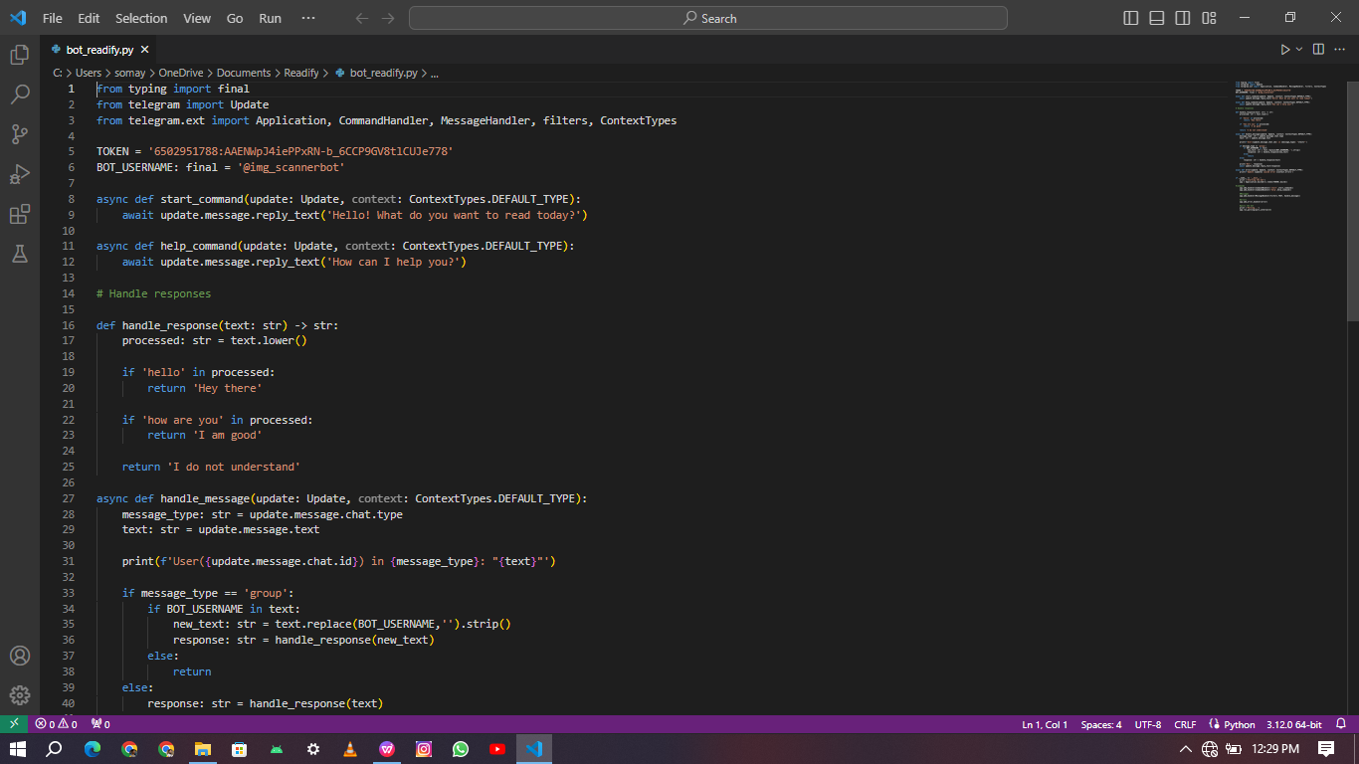

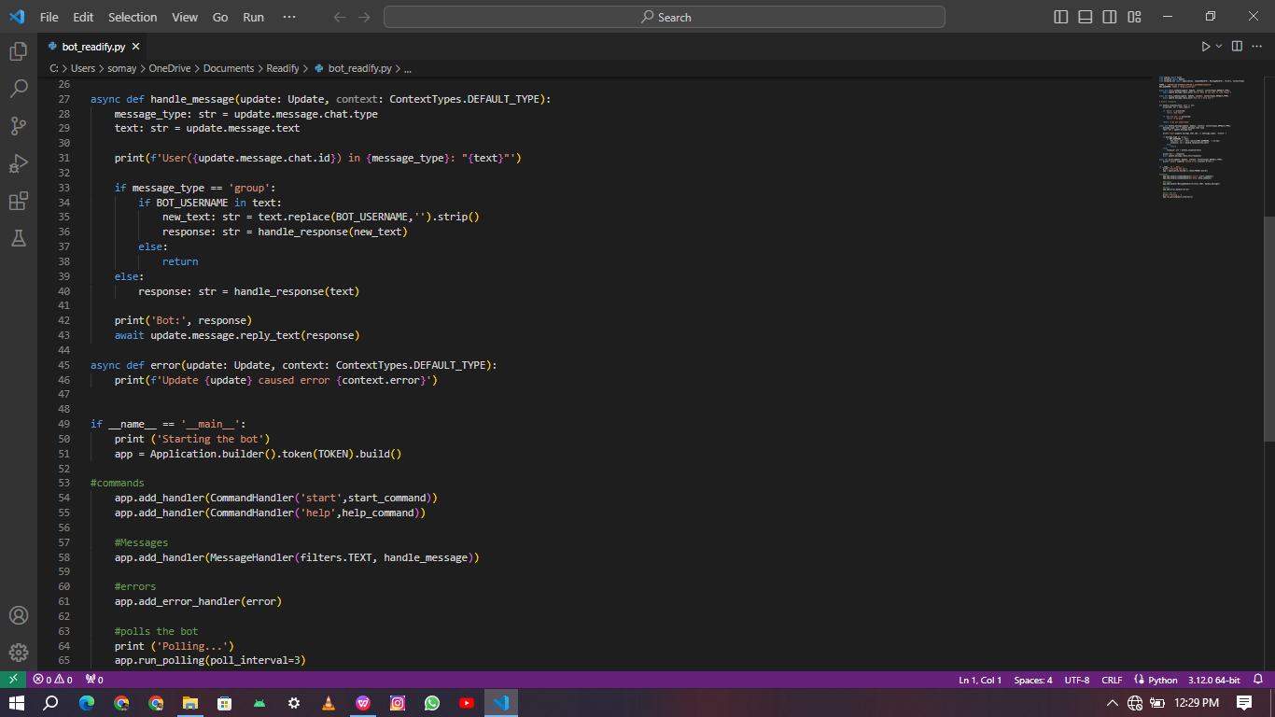

## TABLE OF CONTENTS

1. **INTRODUCTION**

1.1Problem Statement.......................………………………………………………

1.2 Objective of Proposed System…………………………………………............

* 1. Proposed System Architecture……………………………………………….…
  2. Scope of the Proposed System …………………………………………………

1.5 Feasibility Study………………………………………………………………..

1.5.1 Technical Feasibility…………………………………..........

1.5.2 Economic Feasibility……………………………………......

1.5.3 Financial Feasibility…………………………………...........

1.5.4 Safety Feasibility……………………………………............

## SYSTEM ANALYSIS

2.1 User Interface….......................................................................................................

2.2 H/W Requirements……………………………………………….........................

2.3 S/W Requirements………………………………………………..........................

2.4 Introduction of Tools………………………………………….............................

2.5 Requirements Specification……………………………………..........................

## SYSTEM DESIGN

3.1 System Functionality …………………………………………………………..

3.2 System Modules ………………………………………………………………...

3.3 Database Design……………………………………………………………….

3.4 Form Design, Outputs ……………………………………………....................

## TESTING & TEST RESULTS

4.1 Objective of Testing…………………………………………..............................

4.2 Step in Testing……………………………………………….................................

4.3 Level of Testing…………………………………………….................................

4.3.1 Unit Testing………………………………………………………....

4.3.2 System testing……………………………………………………..

4.3.3 Integration testing…………………………………………………

4.3.4 Acceptance Testing…………………………………..........................

4.4 Testing Strategy for Proposed System………………………………....

4.5 Testing Analysis…………………………………………..............................

## SYSTEM IMPLEMENTATION

5.1 System Coding ………………………………………………………………….

## SUMMARY AND CONCLUSIONS

6.1 Summary …………………………………………………………….

6.2 Limitations of the System…………………………………………………..

6.3 Improvements ……………………………………………………………..

6.4 Conclusion………………………………………………………………….

6.5 Future Scope …………………………………………………………………

**REFERENCES** ……………………………………………………………………

**APPENDIX**………………………………………………………………….

# INTRODUCTION

## TABLE OF CONTENTS

Readify is an advanced project that combines artificial intelligence, natural language processing, and Python programming to create an intelligent Telegram chatbot. The primary purpose is to continuously deliver curated articles on various topics, including science, infotainment, finance, and technology, at regular intervals of 15 minutes. Additionally, Readify introduces a unique feature that facilitates one-to-one conversations through Python modules, enhancing user engagement and personalization, Moreover, Readify ensures uninterrupted service by integrating with AnytimePython for 24/7 hosting.

**Technical Feasibility:**

Users subscribe to Readify through the Telegram platform.

The chat-bot initiates content delivery every 15 minutes.

Users can engage in one-to-one convo, providing personalized experience.

**Economic and Financial Feasibility:**

Web scraping fetches relevant articles from trusted sources.

The AI algorithms categorize articles based on user preferences.

Scheduled delivery ensures a steady stream of articles to users.

**Safety Feasibility:**

Python modules analyze user input, considering context and sentiment.

Dynamic responses enhance the conversational experience.

## SYSTEM ANALYSIS

**Platform**

**Operating System:** Windows 10, Android OS and IOS

## Technologies Used:

***Programming Languages:*** Python for the back-end, integrating libraries like NLTK (Natural Language Toolkit) for NLP and machine learning.

***Telegram API:*** Utilized for seamless integration with the Telegram platform.

***Database:*** Stores user preferences and historical interactions for personalized content recommendations.

***Web Scraping:*** Employed to fetch articles from reliable sources.

# Software Requirements

* Visual Studio
* Python IDE
* Telegram Account

# Hardware Requirements

* Minimum Processor I3 Required
* Hard Drive Minimum 500gb
* RAM Minimum 4GB
* Stable Internet Connection

## SYSTEM DESIGN

Systems design is the process of defining the architecture, components, modules, interfaces, and data for a given system to satisfy specified requirements. Systems design could be the application of various systems theory to product development. There is some overlap with the disciplines of systems analysis, systems architecture and system designing.

## The Readify system architecture comprises Four main components:

## **Telegram Integration Module**: This module establishes the connection between the Telegram platform and the Readify chat-bot. It handles incoming user requests, processes commands, and delivers responses.

## **Content Delivery Module**: The heart of Readify, this module utilizes AI algorithms for content curation. It fetches relevant articles from predefined sources, categorizes them based on user preferences, and schedules automated delivery every 15 minutes.

## **Conversational AI Module:** This module is responsible for enabling one-to-one conversations. It utilizes Python modules for natural language processing, sentiment analysis, and context-aware responses, creating a dynamic and personalized user experience.

## **24/7 Hosting**: AnytimePython integration ensures continuous hosting. The system remains operational without downtime.

## 4.TESTING & TEST RESULTS

**RESPONSE TIME TEST ID:**

Objective: To make sure that the system respond back time is efficient. Description: Time is very critical in a voice based system. As we are Not typing inputs, we are speaking them. The system must also reply in a moment. User must get instant response of the query made.

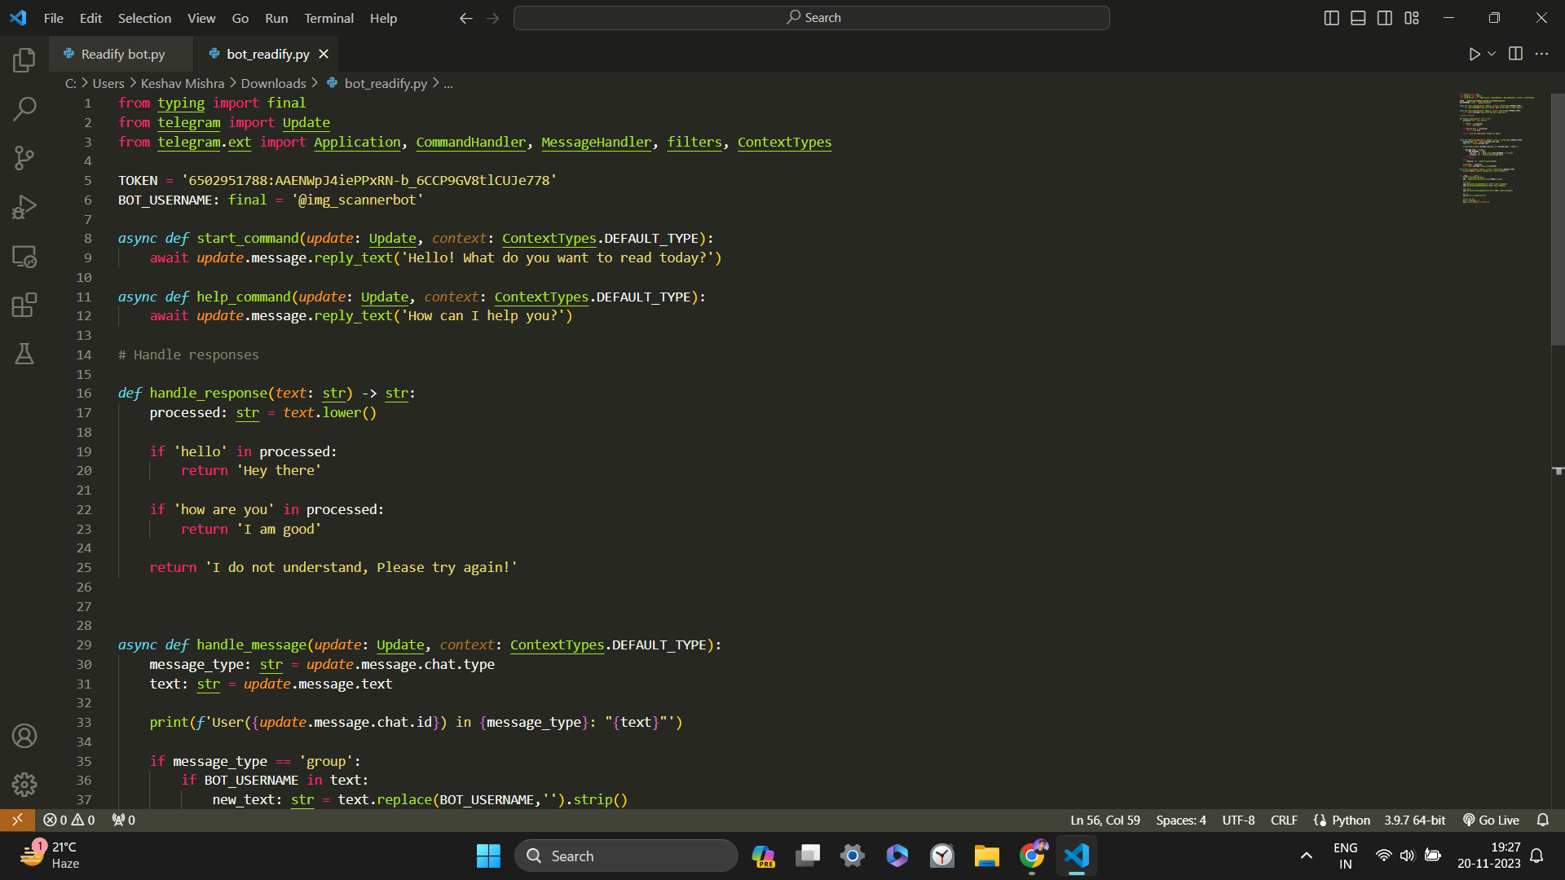

## ACCURACY TEST ID:

Objective: To assure that answers retrieved by system are accurate as per gathered data. Description: A virtual assistant system is mainly used to get precise answers to any question asked. Getting answer in a moment is of no use if the answer is not correct. Accuracy is of utmost importance in a virtual assistant system.

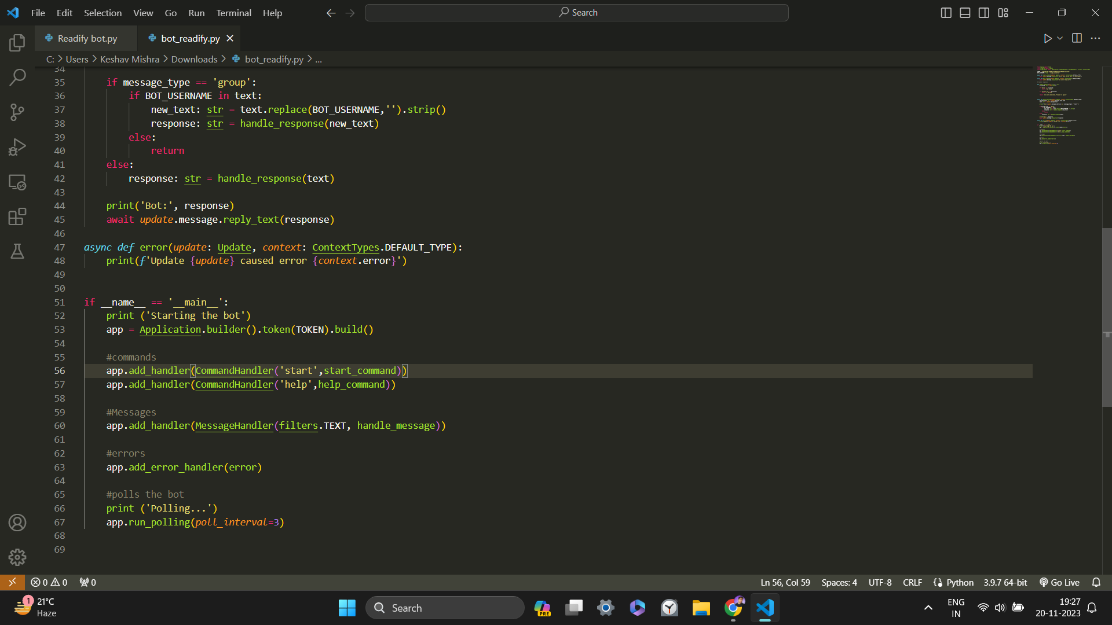

## APPROXIMATION TEST ID:

Objective**:** To check approximate answers about calculations. Description: There are times when mathematical calculation requires approximate value.

For example, if someone asks for value n f pi the system must respond with approximate value and not the accurate value. Getting exact value in such cases is undesirable.

## 5.SYSTEM IMPLEMENTATION

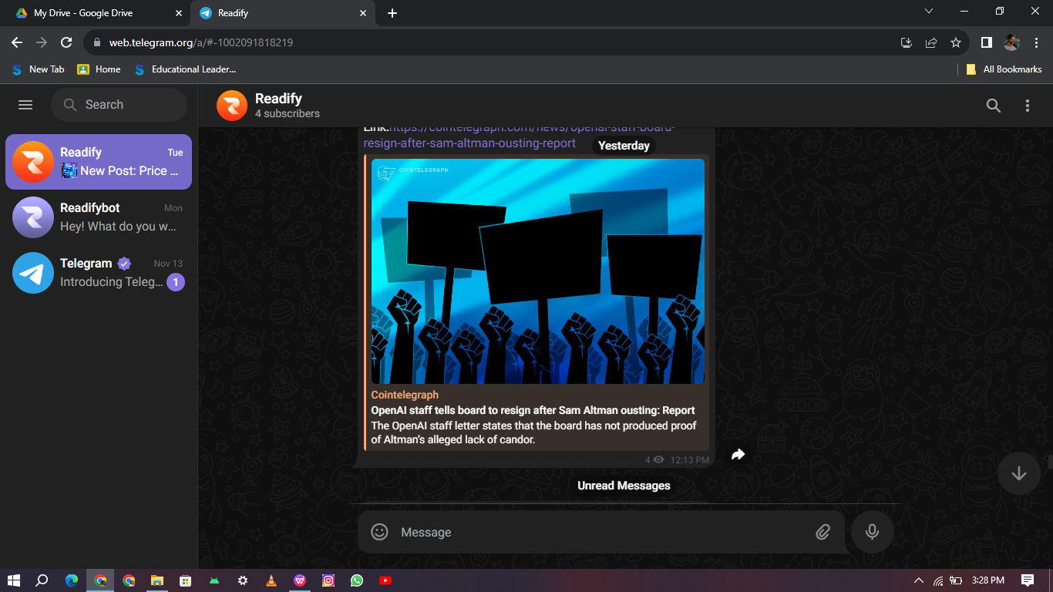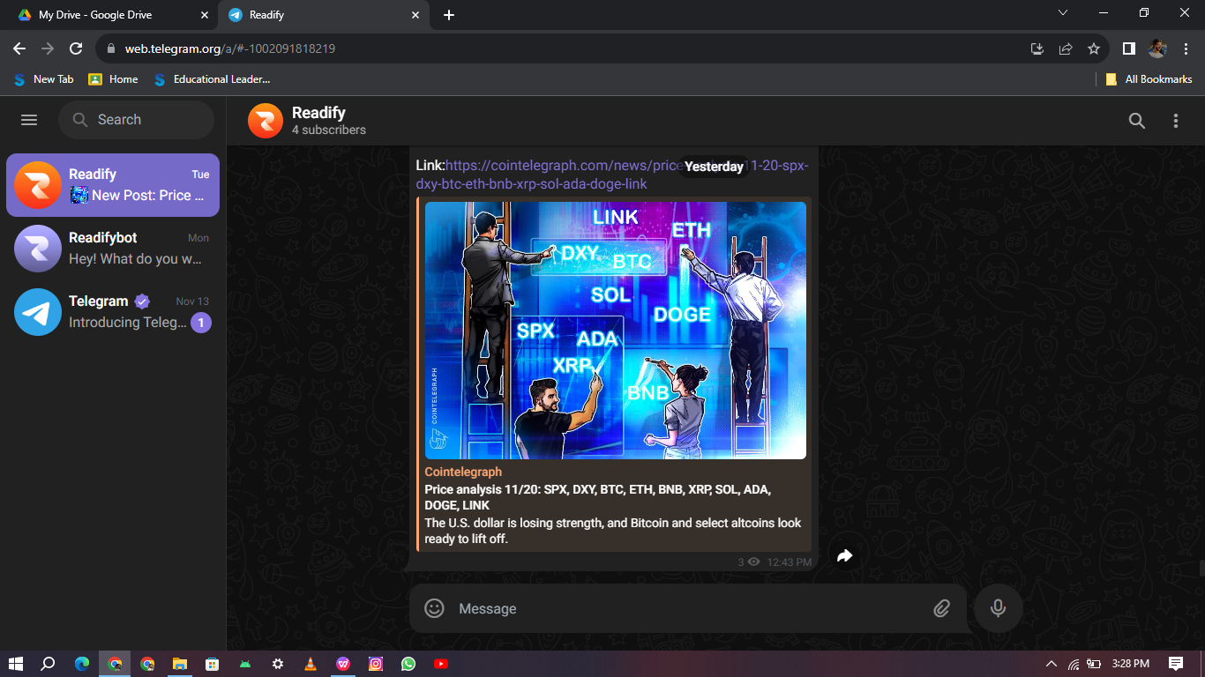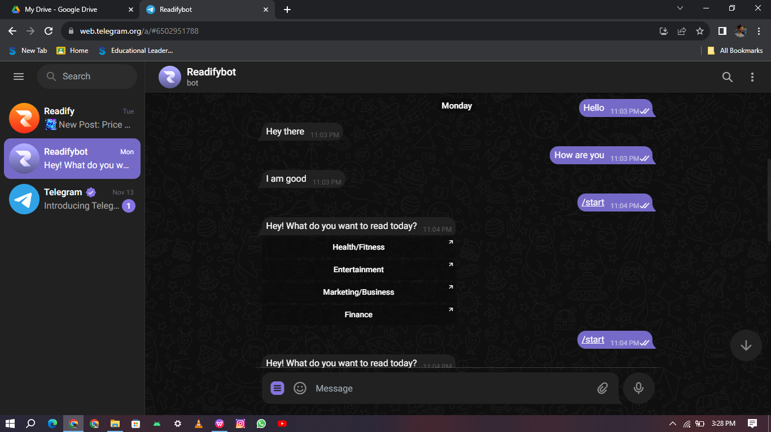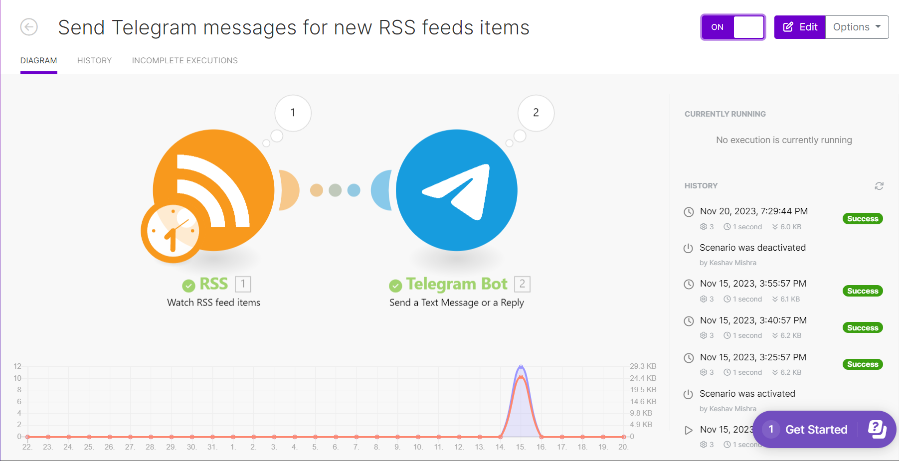

**6.SUMMARY AND CONCLUSIONS**

In this project, we have introduced a Readify bot that is able to interact with users. This Readify bot can answer queries in the textual user input. For this purpose, AIML with program-o has been used. The Readify can answer only those questions which he has the answer in its AIML Dataset. So, to increase the knowledge of the Readify, we can add the API s of Wikipedia, Weather Forecasting Department, Sports, News, Government and a lot more. In such cases, the user will be able to talk and interact with the Readify in any kind of domain.

Using API s like Weather, Sports, News and Government Services, the Readify will be able to answer the questions outside of its datasets and which are currently happening in the real world.

The next step towards building Readify involves helping people to facilitate their work and interact with computers using natural language or using their set of rules. Future Such Readify, backed by machine-learning technology, will be able to remember past conversations and learn from them to answer new ones.

The challenge would be conversing with the various multiple bot users and multiple users. As future work, we can make a Readify that is based on AIML and NLP. This technology will enable a client to interact with a Readify in a more natural fashion. We can enhance the discussion by including and changing patterns and templates for general client queries using AIML and the right response are given more often than NLP.

## FUTURE PERSPECTIVE

There are limitations to what has been currently achieved with “Readify”. The limitations of data processing and retrieval are hindering Readify to reach their full potential. It is not that we lack the computational processing power to do so. However, there is a limitation on “How” we do it.

Major Future tendencies include:

# Multimedia Integration: Enhance Readify by incorporating multimedia content such as videos, podcasts, and interactive visuals alongside articles. This expansion will cater to diverse learning preferences and offer a more engaging user experience.

# Enhanced Personalization: Implement advanced machine learning techniques to analyze user interactions and feedback. This will enable Readify to continuously refine content recommendations, ensuring a highly personalized experience tailored to individual preferences.

# Community Engagement: Introduce community-driven features, allowing users to share, discuss, and recommend content within the Readify platform. Incorporate social elements to foster a sense of community and collaborative learning.

# Voice Interaction: Explore the integration of voice-based interaction to make Readify accessible to a wider audience. Incorporate natural language processing for voice commands and responses, enhancing the overall user experience.

# Real-time Updates: Integrate real-time content updates to provide users with the latest information. Implement a system that can push urgent or trending articles instantly, ensuring users stay informed about breaking news and emerging trends.

# REFERENCES

1. Bayan Abu Shawar and Eric Atwell, 2007 “Readify: Are they Really Useful?”

1. LDV Forum - GLDV Journal for Computational Linguistics and Language Technology.
2. http://www.ldv-forum.org/2007_Heft1/Bayan_AbuShawar _and_Eric_Atwell.pdf
3. Bringing Readify into education: Towards natural language negotiation of open learner models. Know.- Based Syst. 20, 2 (Mar. 2007), 177-185.
4. Intelligent Tutoring Systems: Prospects for Guided Practice and Efficient Learning. Whitepaper for the Army's Science of Learning Workshop, Hampton, VA. Aug 1-3, 2006.
5. https://en.wikipedia.org/wiki/Chatterbot
6. ALICE. 2002. A.L.I.C.E AI Foundation, <http://www.alicebot.org/>

1. Kumar, M Naveen, PC Linga Chandar, A Venkatesh Prasad, and K Sumangali (2016). “Android based educational Readify for visually impaired people”. In: International Conference on Computational Intelligence and Computing Research (ICCIC), 2016 IEEE. IEEE, pp. 1–4.
2. Ranoliya, Bhavika R, Nidhi Raghuwanshi, and Sanjay Singh (2017). “Readify for University Related FAQs”. In: 2017 International Conference on Advances in Computing, Communications and Informatics (ICACCI). Udupi, pp. 1525–1530.